2. **Serene Escape 🌊**

One of our members has found a place so serene that they practically live there. Your mission is to uncover the name of the dam associated with this tranquil reservoir

**Solution: Malampuzha Dam (Location: Palakkad, Kerala, India)**

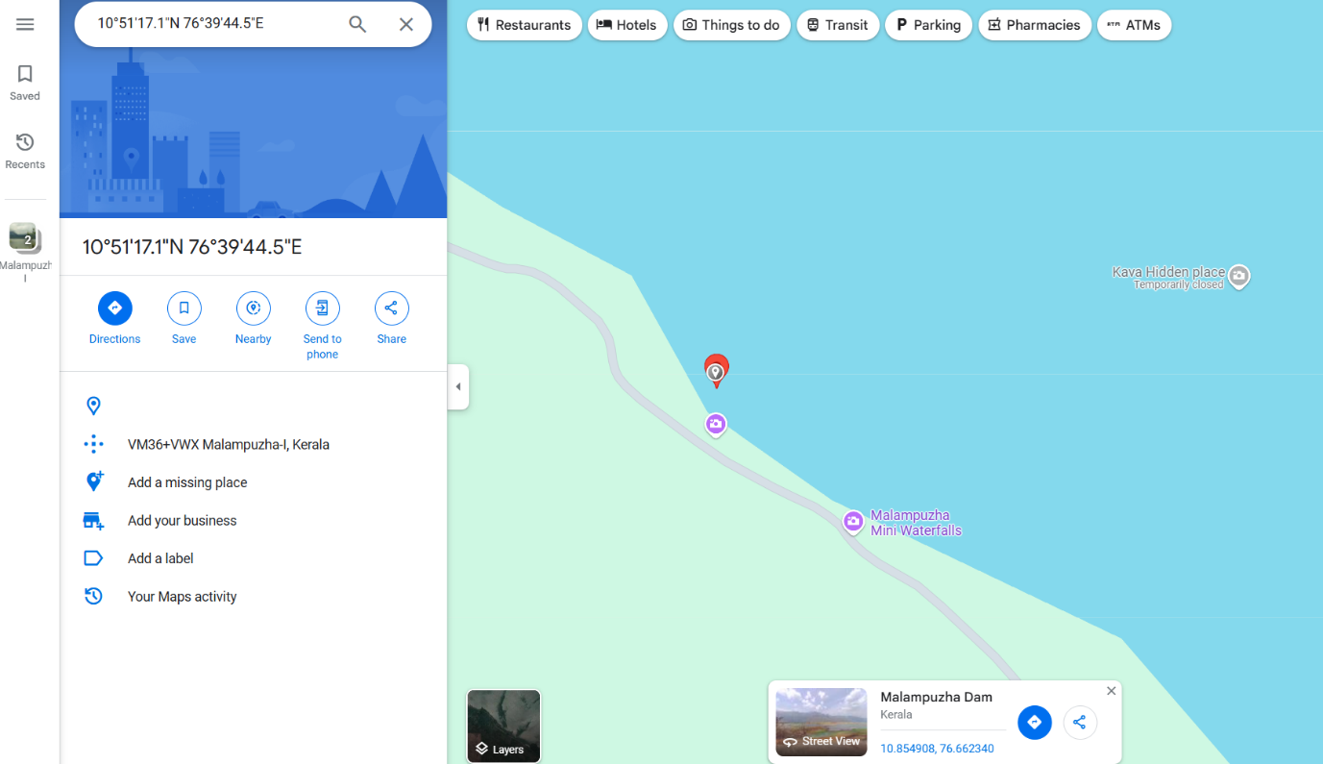

**Approach:**

**Analysis of the Encoded Title**

**Upon examining the image properties, the title is identified as:**

**Title: MTAuODU0NzUzOTg4MzcyNjYyLCA3Ni42NjIzNjg3MDgwNzU3Mwo=**

**The presence of the = at the end indicates that the title is encoded in Base64. By performing Base64 decoding, the following latitude and longitude values are obtained:**

* **Latitude: 10.854753988372662**
* **Longitude: 76.66236870807573**

**These coordinates were subsequently input into Google Maps, revealing the location as Malampuzha Dam.**